DATA STRUCTURES
LAB 14
NAME : Minahil Tanveer
SAP ID: 69092
SUBMITTED TO: Mam Nehan sehar
TASK #1
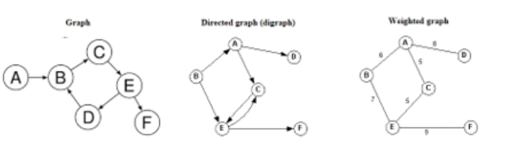
• Make Adjacency Matrix of above graphs.
• Make Adjacency list of above graphs.
• Perform BFS.
• Perform DFS.
SOLUTION:

1) Undirected Graph

Edges (from diagram):
- A — B
- B — C
- B — D
- C — E
- D — E
- E — F

Adjacency List:
- A → B
- B → A, C, D
- C → B, E
- D → B, E
- E → C, D, F
- F → E

Adjacency Matrix:
 | A | B | C | D | E | F
A | 0 | 1 | 0 | 0 | 0 | 0
B | 1 | 0 | 1 | 1 | 0 | 0
C | 0 | 1 | 0 | 0 | 1 | 0
D | 0 | 1 | 0 | 0 | 1 | 0
E | 0 | 0 | 1 | 1 | 0 | 1
F | 0 | 0 | 0 | 0 | 1 | 0

BFS (starting A):
A → B → C → D → E → F

DFS (starting A):
A → B → C → E → D → F

2) Directed Graph (Digraph)

Interpreted edges:
- A → C
- A → D
- B → A
- B → E
- C → E
- E → C
- E → F

Adjacency List:
- A → C, D
- B → A, E
- C → E
- D → —
- E → C, F
- F → —

Adjacency Matrix:
 | A | B | C | D | E | F
A | 0 | 0 | 1 | 1 | 0 | 0
B | 1 | 0 | 0 | 0 | 1 | 0
C | 0 | 0 | 0 | 0 | 1 | 0
D | 0 | 0 | 0 | 0 | 0 | 0
E | 0 | 0 | 1 | 0 | 0 | 1
F | 0 | 0 | 0 | 0 | 0 | 0

3) Weighted Graph

Interpreted weighted edges:
- A — B = 6
- A — D = 8
- A — C = 5
- B — D = 7
- C — E = 5
- D — E = 6
- E — F = 9

Weighted Adjacency List:
- A → B(6), C(5), D(8)
- B → A(6), D(7)
- C → A(5), E(5)
- D → A(8), B(7), E(6)
- E → C(5), D(6), F(9)
- F → E(9)
TASK #2
Draw a graph modes, starting the type of graph used, to represent airline routs where every day there are four flights from Boston to Newark, two flights from Newark to Boston, three flights from Newark to Miami, two flights from Miami to Newark, one flight from Newark to Detroit, two flights from Detroit to Newark, three flights from Newark to Washington, two flights from Washington to Newark, and one flight from Washington to Miami, with (1) an edge between vertices representing cities that have a flight between them (in either direction) (2) an edge between vertices representing cities for each flight that operates between them) in either direction) (3) an edge between vertices representing cities for each flight that operates between them (in either direction) plus a loop for a special sightseeing trip that takes off and lands in Miami
SOLUTION:
Cities: Boston, Newark, Miami, Detroit, Washington
Directed Multigraph:
Boston → Newark (4)
Newark → Boston (2)
Newark → Miami (3)
Miami → Newark (2)
Newark → Detroit (1)
Detroit → Newark (2)
Newark → Washington (3)
Washington → Newark (2)
Washington → Miami (1)
Miami → Miami (loop for sightseeing)

Graph Types:
(1) Simple undirected graph (only connection existence)
(2) Multigraph (multiple flights considered)
(3) Directed multigraph + loop at Miami
TASK#3
Describe a graph model that represents whether each person at a class knows the name of each other person at the class. Should the edges be directed or undirected? Should multiple edges be allowed? Should loops be allowed?
SOLUTION :

Graph Type: Undirected Simple Graph
Reason:
If one student knows another, relation is mutual
Edges:
No multiple edges
No loops allowed

TASK#4
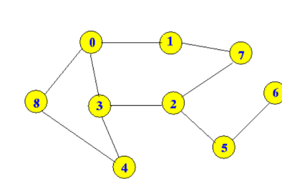
- Perform BFS.
- Perform DFS.
SOLUTION:

BFS (Breadth First Search)
Level by level:
BFS Order:
0 → 1 → 3 → 8 → 7 → 2 → 4 → 6 → 5

DFS (Depth First Search)
Go as deep as possible first:
DFS Order:
0 → 1 → 7 → 2 → 3 → 4 → 5 → 6 → 8

____________________________________________________

